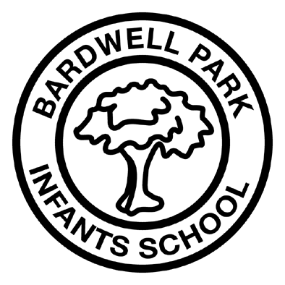
Bardwell Park Infants School
4 Crewe Lane Bardwell Park
NSW 2207
t: 95678754 f: 9567 2952
e: bardwelpki-p.school@det.nsw.edu.au
w: https://bardwelpki-p.schools.nsw.gov.au/

Dear parents and carers,
Thank you for responding to our recent communications survey. Your positive, constructive contributions have now been incorporated with information from the Department of Education Social Media Team to create the official Bardwell Park Infants School Facebook page.
This powerful and positive tool will allow us to let the wider community know about the many wonderful learning opportunities Bardwell Park Infants School offers. We will be celebrating what makes our students, staff and school great.
As always, the safety of our students is paramount: so, we have adopted the Department of Education guidelines to eliminate or at least minimise potential issues arising from the misuse of social media. These monitoring and wellbeing measures include;
- only posting photos of students who have permission to publish. Parents and carers were given the choice to permit publication of their child/ren when completing the enrolment process.
- parents and carers who have already given permission to publish can withdraw it at any time by contacting the school.
- names are not disclosed in any Facebook publication unless prior permission is sought from the parent or carer.
- all staff, parents, carers and the community are expected to post comments, information and/or photos in a respectful way.
- engagement with the Bardwell Park Infants School Facebook page is set out clearly in the ‘About’ tab. By posting anything on the page you are agreeing to those terms of engagement.
- a link to the Facebook page will be placed on the Bardwell Park Infants School website
- Facebook accounts are restricted to students aged 13 years or older.
More information about the Department of Education's social media policy is available at; https://education.nsw.gov.au/about-us/social-media/official-school-social-media-rules-of-engagement
Further information about Facebook can be found at; https://www.facebook.com/help/160672070698623
We are looking forward to launching our new official Bardwell Park Infants School Facebook page later in the week. We will update you on the launch and welcome your involvement in this exciting development.
Kind regards,

Mrs Michelle Waring
Relieving Principal
Bardwell Park Infants School

